The Dystopian Trend in Young Adult Literature, and its Ties to Postmodernism
Kelly A. Sporrer
Sonoma State University

Abstract
One simply has to peruse the young adult isle in any bookstore to see the overwhelming popularity of young adult (YA) dystopian literature on the shelves. In fact, that prevalence has transcended into the major motion picture industry as well, with multiple novels within this genre now gracing the big screen: Ender’s Game, Catching Fire, and now Divergent to name a few from this year alone. Witnessing the impact of this trend in my own 8th grade classroom, I was motivated to explore it further. This paper will look through a cultural lens at the rationale behind this growing trend, reflecting on prevalent YA dystopian novels, as well as reflective analyses from experts in the field. Additionally, this paper will connect the cultural trend of dystopian literature to the theory of postmodernism, examining several theorists whose philosophies can be readily linked to universal themes within the dystopian genre. Finally, I will be examining authentic ideas and connections made by my own students as they embark on their journey through the world of dystopia within our classroom literature circles. I will be referring to multiple cultural artifacts in this paper including several dystopian novels: Suzanne Collin’s The Hunger Games, Ray Bradbury’s Fahrenheit 451, Scott Westerfield’s Uglies, Lois Lowry’s The Giver, and Kristen Landon’s The Limit. I will also share some of my students’ written, spoken, and artistic reflections as they take on the dystopian worlds through their literature circle groups.
Keywords: utopia, dystopia, postmodernism

The Dystopian Trend in Young Adult Literature, and its Ties to Postmodernism
Young adult (YA) literature is a unique genre that has seen amazing growth in the consumer market over the last decade. With our youth being more connected than ever before, they are the perfect target consumer for authors and publishers to relay their messages through the written word. How does YA literature differ from Children’s literature? As Roberta Trites, author of Disturbing the Universe: Power and Repression in Adolescent Literature (2004) would say, “Children’s literature often affirms the child’s sense of Self, and his or her personal sense of power” (p. 6). This type of literature supports a child’s sense of security and place, which is often centered on family and home. YA literature, however, takes a drastic turn when our adolescents begin to interact in society. Hence, we enter the world of young adult (YA) dystopian literature. Trites continues, describing the transformation into YA dystopian literature:
In the adolescent novel, protagonists must learn about the social forces that have made them what they are. They learn to negotiate the levels of powers that exist in the myriad of social institutions within which they must function, including family; school; the church; government; social constructions of sexuality, gender, race, class, and cultural mores surrounding death (Trites, 2004, p. 6).
Young Adult Dystopian Literature
The article “The Dystopian Trend in Young Adult Literature,” written by alchive (pseudonym) of Teen Ink, gives an overview of what YA dystopian literature is, and addresses some of the rationale behind its popularity. “YA dystopian literature’s purpose is to teach teenagers about the real world by using young adult protagonists.” (alchive, 2013). Dystopian literature novels are the present day equivalent of fables; “cautionary tales” about modern society. Dystopia, a term that literally translates to “bad utopia,” encompasses novels that reflect on problems seen in current societies. In essence, YA dystopian novels are classic Hero’s Journeys, wherein, the protagonist’s ultimate boon is to save the society that has been destroyed by the prior generations, in particular irresponsible adults (and mainly controlling politicians). In contrast to utopian novels, which are indicative of “any idealized place, state, or situation of perfection” (Guralnik, 1972, p. 1565), dystopian novels present problematic situations that are prevalent in our current culture, which are then exaggerated to the extreme of the worst case scenario. This method is very effective at heightening the awareness of the potential dangers that could arise if society continues down the chosen path.
So why focus on young adults? Teenagers are, in fact, the perfect target audience for this genre for multiple reasons. They are beginning to make abstract, cognitive connections, which extend to their own society. Additionally, they are starting to examine their own place within it, asking themselves, “Do I belong?” Physiologically, teenagers are beginning to question authority and are making the shift from being dependent children, to independent adults. As Trites confirms, “Teenagers, who are beginning to question authority but are still contained by it, are the obvious choice for protagonists” (Trites, 2004, p. 16). Likewise, since this is also a time where teenagers identify with, and are highly concerned with their social status, they become the perfect and clear choice for the protagonist characters within these novels. This time of flux is one where children are easily influenced; what better audience for a dystopian author? Today’s teenagers are tomorrow’s decision makers, and dystopian literature is a medium for examining and discussing topics of concern within our society.
One of the biggest controversies surrounding YA dystopian novels is the overwhelming violence that is woven within the plot lines. This is especially prevalent as the post-apocalyptic setting has taken center stage. Critics argue that this saturation of violence is desensitizing teens who are no longer fazed by it. Some believe that it is pushing teens to act against social norms, and that these novels are introducing our youth to topics beyond their understanding. “But, violence committed by and against children has a long, grisly tradition in literature – as an allegory for adult cruelty, a representation of the emotional volatility of adolescence and a tension-raiser for audiences” (Keegan, 2012). The drama and violence of such dystopian tales as Hunger Games may be that which is most appealing to adolescents, who are experiencing a crucial stage of emotional development. “Taking the kids from our districts, forcing them to kill one another while we watch – this is the Capitol’s way of reminding us how totally we are at their mercy” (Collins, 2008, p. 18). In Keegan’s article, adolescent psychologist, Harold Koplewicz comments, “‘Between the ages of 11 and 24, your brain is going through a remarkable revolution…your emotional development is accelerated before your impulse control. You’re freezing, you’re boiling, you hate everyone, you love them. You have very deep and well-felt emotions but it’s very hard’” (Keegan, 2012). Teens are always contemplating the “What if?” Reading dystopian novels and experiencing the emotions and triumphs of protagonists of the same age, may in fact be cathartic for some adolescents.
The Link to Postmodernism
Arguably, YA dystopian literature is a direct product of postmodernism. Roberta Trites succinctly breaks down the stages of literature into three eras: Romanticism, Modernism, and Postmodernism. Romanticism is where “society is legitimized”; Modernism shifts the focus to individuals; and finally, Postmodernism begins to question how the government and society interact with their individuals. Trite claims that dystopian literature came out of the Modern era; young adult literature came out of the Romantic era; and young adult dystopian literature is the combined product occurring in the Postmodern era. (Trites, 2004, p. 17). In fact, Trites believes that without postmodernism, YA dystopian literature would not exist. For adolescents, the focus is certainly the future. Students who are studying utopian and dystopian novels are grappling with the questions of “what we want, what we can change, what we must fight, and what we must endure to be ready for the future” (Ridley, 1983). Ridley, who uses the study of dystopian novels in her own classroom, challenges her students to answer some of the key questions sparked by the genre. “What elements in our own society frightened the author? Is his or her view correct? If these elements are allowed to grow unchecked, could we have the society portrayed on one of these novels?” (Ridley, 1983)
In a telling interview with Bill Moyers on Moyers and Co., renowned postmodernist and philosopher, Henry Giroux argues that “all things that make democracy viable are in crisis” (Moyers & Co., 2013) In fact, it is that forecast of impending doom that is the driving force behind dystopian literature. According to Giroux, “America is descending into madness” (Moyers & Co, 2013). Through this hyperbole, Giroux explains that in all exaggeration, there is truth. This is precisely the crux of YA dystopian literature; it is a world that is experiencing the extremes of what could be the manifestation of current social, political, and economic realities.
Although not the first book to expose adolescents to the pessimistic future of dystopian worlds, Lois Lowry’s novel The Giver, certainly started the landslide of popularity for this genre. “Its success was dependent on the emotional connection that Lowry created between her protagonist and her young readers” (alchive, 2013). “We really have to protect people from wrong choices” (Lowry, 1993, p. 99). These words, spoken by Jonas from Lois Lowry’s The Giver, were an ominous declaration of a twisted Utopian fantasy. During a discussion between the protagonist, Jonas, and the Giver, the keeper of all memories, the Giver explains that “we gained control of many things. But we had to let go of others” (Lowry, 1993, p. 99). Although the content of their discussion revolved around the seemingly benign subject of color, the idea that any choice would lead to citizens wanting to exercise more and more freedom of choice, could be detrimental to the society.
The theme of unity and sameness is a popular one among many dystopian novels such as, The Giver, Divergent, and The Hunger Games. However, by creating sameness within the community, what is really occurring within the society is the separation and control of its citizens through compartmentalization. Here we see another affirmation of postmodernism at hand. As P. Slattery (2006a) states, “In the process of creating something, something else inevitably gets left out. These exclusive structures can become repressive – and that repression comes with consequences” (p. 4).
Giroux would confirm that there is indeed something being left out, and that is our youth. He sees society creating a generation of disposable youth, one he refers to as “zero people” (Moyers & Co, 2013). With our schools and classrooms resembling malls, and curriculum that is in essence written by large corporations, Giroux raises the question of “where are public spaces where students can learn about the non-commodifiable discourses: trust, justice, honesty, integrity, caring compassion – they are absent in the commodifiable” (Moyers & Co., 2013). Giroux is convinced that Capitalism is in control of Democracy, and that control extends to every aspect of our culture’s young people. With such clear evidence, he questions why we, as an intelligent society, are not outraged by the current state of affairs. In Giroux’s work, Zombie Politics and Culture, he sees the trend moving toward a militant state which “shifts away from the hope that accompanies the living, to a politics of cynicism and despair” (Moyers & Co., 2013).
Although Giroux paints a bleak picture of our current society, he still believes that we can create a constructive civilization out of our current state; there are many positive movements that are altruistic at their center. Even though these movements are currently fragmented, Giroux believes that with the right access point for discussion, these movements can combine and emerge victorious in our society. With enough rage, we can begin a dialogue of hope. “To act otherwise, you have to imagine otherwise and put in the hard work – believe in the struggle and invest in the struggle” (Moyers & Co., 2013). In fact, as many major victories in our history will attest to, there can be joy in the struggle; hope is a very strong motivator and an altruistic vision can indeed become a reality. There is a historical parallel seen our own Declaration of Independence which states that if the voice of the people is not heard and their interests are not represented through a tyrannical system, we have the right and the responsibility to change it no matter what the cost. It is arguable that YA dystopian literature is a means to an end of communicating the realities of the current situation as outlined by Giroux, bringing that outrage to the forefront of the minds of our youth. Authors such as Ray Bradbury also mimic this hopeful outlook in his classic dystopian novel Fahrenheit 451. “We need not to be let alone. We need to be really bothered once in a while. How long is it since you were really bothered? About something important, about something real?” (Bradbury, 1953, p. 52)
In her article, “Shining the Light on Dystopian Young Adult Literature,” author Diane Colson (2012) would completely agree that the difference in adult dystopian literature and YA dystopian literature is the concluding vision of hope. Although in both of these genres everything may be destroyed by the end of the book, unlike their adult counterparts, teen novels “end with a glimmer of hope… we have the courage and vision to begin anew” (Colson, 2012). Because the protagonists of YA dystopian literature are indeed teenagers themselves, they are incredibly intriguing and identifiable to their adolescent followers. By the end of the novel, “there is an uplifting sense of triumph when young people defy all of the obstructions of a repressive society and emerge whole, with a new sense of power” (Colson, 2012). The sense of a hopeful future is what keeps our youth reading. This message is eloquently expressed in Bradbury’s timeless novel. “That's the wonderful thing about man; he never gets so discouraged or disgusted that he gives up doing it all over again, because he knows very well it is important and WORTH the doing” (Bradbury, 1953, p. 153).
power in the dystopian world. Enter the world of Power. Those who control the power, control the actions of all others. It is to this unjust, and sometimes unseen, power that citizens of dystopian worlds become prey. The uneven distribution of power is at the core of all conflicts that arise within dystopian societies. To Trites, this is the key to adolescent literature. Teenagers “must learn to balance their power with their parents’ power and with the power of other authority figures in their lives” (Trites, 2004, p. iv). In Suzanne Collins’s Hunger Games there is a distinct separation of power between the rich and the poor. The balance is so askew, that the government is willing to sacrifice its young to continue to hold that power. The citizens’ lack of power allow this barbaric tradition to continue from generation to generation. However, “without experiencing the gradations between power and powerlessness, the adolescent cannot grow. Thus, power is even more fundamental to adolescent literature than growth” (Trites, 2004, p. iv). Subsequently, through this imbalance of power emerges the spark of defiance and ultimately hope. “Only I keep wishing I could think of a way to…to show the Capitol they don’t own me. That I’m more than just a piece in their Games” (Collins, 2008, p. 142). These are the words spoken by Peeta Melark, one of the main characters in Collins’s novel, and is the universal message prevalently expressed by our adolescents; they want control of their lives and are very keen and outspoken on what they perceive as justice and fairness.
Paulo Freire is another theorist who recognizes that he who holds control of dialogue, holds the power in any relationship. In his work, Pedagogy of the Oppressed, Freire expresses:
Dialogue cannot occur between those who want to name the world and those who do not wish this naming – between those who deny other men the right to speak their word and those whose right to speak has been denied them. Those who have been denied their primordial right to speak their word must first reclaim this right and prevent the continuation of this dehumanizing aggression (Flinders & Thornton, 1970, 1993, p. 157).
Those in power indeed control everything, including the dialogue between their citizens. By suppressing the dialogue among citizens, we are in essence controlling and writing the history of our world. In Bradbury’s, Fahrenheit 451, all written dialogue is seen as being so powerful, that those who are afraid of its power order all books destroyed. “There must be something in books, something we can’t imagine, to make a woman stay in a burning house; there must be something there. You don’t stay for nothing” (p. 51). Indeed, there is something in books, in the words on the page that move and motivate people beyond what they believe capable. In his article, “The Road to Postmodernism Through Dystopia: A Comparative Analysis of 1984 and Brave New World,” (2009), Scott Boulding would absolutely support that “language is also viewed as a tool for supporting the dominant power group within a society.” As language is a culturally based phenomena, the few powerful keepers of the dialogue are very influential in what messages are delivered to that culture and its residents. They can share or hide information as they deem fit, and the vast majority of the citizens are kept in the dark. For some this ignorance may indeed be bliss, until they are so far removed from the culture’s dialogue that they can no longer recognize that they are being exploited.
Language is seen as shaping the very way in which individuals construe reality; and, since it is biased in favor of the dominant group, theirs is the reality that gains ascendancy (“Postmodernism”). Postmodernists are keenly interested in power relationships between groups, and the ways in which dominant groups seek to maintain their dominant status. As a rule, they tend to champion so-called subcultures and align themselves with those fighting against the established power structures (Boulding, 2009).
The ties between language, culture, and power are evident. As Postmodernists are most interested both in how these systems interact, and how they create our current and future establishments, it is no wonder that the link to YA dystopian literature is so evident. Like the postmodernists’ mission to balance the power structure, it is also the dystopian authors’ mission to create a socially savvy and sympathetic protagonist to balance the power of their flawed society. Inspiring that kind of change is the challenge both of postmodernists and YA dystopian authors today.
According to the Center for a Postmodern World, there are several features that humanity must transcend from modernity to postmodernity. One of these is a post-patriarchal vision where the feminine and masculine are equal (Slatterly, 2006b, p. 20). This is yet another area in which current dystopian literature is displaying evidence of its ties to postmodernism. Many of the present day novels feature fearless female protagonists who are the saviors of their societies. The idea that an adolescent female can not only make informed decisions for herself, but can endure hardships that would defeat even the most resilient adult male, is indeed making a statement for feminine equality. Many of the leading female protagonists are challenged with making those courageous and selfless decisions that allow for their society to triumph and begin anew. The female in essence “births” a new beginning of hope.
Discovery through Literature Circles
The next step in my examination of YA dystopian literature was the exploration of the genre with my own 8th grade students through a five week literature circle unit (Appendix A). The idea for taking on this unit was sparked by a combination of my students’ unsatiable interest in the genre, and our EDCT 585 class’s examination of text excerpts from The Giver and Harry Potter. Literature circles are where the critical questions raised through YA dystopian literature can be authentically examined and discussed with their target, adolescent audience.
Prior to any reading, I implemented an introductory activity unbeknownst to my students. I explained to them that during our literature circle time, I would be introducing a new set of classroom rules and procedures for how literature circles would be run. I let them know that we would be incorporating technologies that we had not used before, and that the new rules would ensure that all students would be treated equally. They would be given roles that would only reflect their strengths; we would be exploring freedoms that we hadn’t explored before.
This was initially met with much enthusiasm and support. However, once I started reading the rules, the classroom demeanor quickly changed. The first rule was that no one would be allowed to talk in class without my permission and that all communication would be via on-line chat in the computer lab. The subsequent rules divided the class into groups based on grades, and that assignments would be given accordingly. Furthermore, there was to be no discussion of historical, cultural, or personal connections during the exchanges. Needless to say, the class was very upset.
Once I explained that the rules were not a reality, and the class settled down, I set them to the task of reflecting on the exercise. The first question was “How would you feel if rules like these were really implemented in one of your classes? Why?” The responses were quite animated and heartfelt. I took all of the responses and typed them into the wordle.com program, which highlights key words; the more often a word is entered, the larger it appears in the montage. I attached the original “wordle” and the visual expression is very powerful (Appendix B). At once you can see that the predominant word was “feel.” I found this to be quite revealing, considering the idea of “feeling” in dystopian literature is quite controversial. As one student wrote, “I would feel powerless, angry, and pushed aside. I would have almost no say, and because you can’t say anything it would be hard to disagree” (Genevieve, personal communication, December 2, 2013). Another wrote, “I would feel rebellious and angry because I feel like it takes away my right.” (Cicero, personal communication, December 2, 2013). Finally, one student commented, “I would feel isolated because it is like being confined to one space. For instance, if we were separated by grades then what about our friends? You’ll just be disregarding our freedom” (Alyssa, personal communication, December 2, 2013). After some discussion with my students, they came to the conclusion that the dystopian characters have strong feelings inside of themselves, but they are not allowed to express their feelings without being punished by those in control.
The next activity I embarked on was “designing your own dystopian baby.” This clever activity tasked the students with choosing genetic features to create their ideal child. The twist is that you are given a strict budget, and each feature choice comes with a price. Some of the features included gender, appearance, ethnicity, height, weight, skin pigment, intelligence level, and “health” bonuses. As you can imagine, the activity was well received, but a few of the students began to see that there were traits that were left off of the list, such as various ethnicities. The discussion became quite vocal as the students were sharing their choices; many exclamations of “that’s racist” or “you’re discriminating against….” were flying as we shared why one person chose a certain ethnicity, character trait, physical trait, or other characteristic. The questions began to fly, which allowed us to discuss the deeper philosophical questions reflected in Slattery’s earlier declaration that, “in the process of creating something, something else inevitably gets left out” (Slattery, 2006a, p. 4). As a class we discussed the dangers of choosing “desirable” traits; if you choose to remove the aging gene, but your child was born with a defect or incurable disease, how would you deal with that? Is it better to have a world where uniqueness is removed and everyone looks the same, or are unique traits valuable in society? As I had hoped, my students were able to make incredible connections with present day advertisements and movies, as well as peer pressures they are experiencing. One of the themes that we explored earlier this year on our outdoor education week is that diversity is our strength. This activity allowed us to revisit that universal truth and reconnect with its meaning as we brought the activity to a close.
One of my morning “quick write” activities challenged the students to reflect on their literature circle meetings thus far, and comment on any connections they could make with issues in our current society, either politically, socially, or economic. One of the groups is reading Kristen Landon’s The Limit, which is centered on the question of what could happen if our credit spending and consumer debt continues unchecked. In the novel, when a family exceeds their “limit” the government takes their children one by one to a working factory, where they must work to pay off their family’s debt. Our conversation evolved out of the responses from a few members from this group. Many of the students began to make connections with the recent government shutdown, which directly affected our classroom’s weeklong outdoor education trip to Yosemite, resulting in our being sent home early. One of my students wrote that she thought that “the author is trying to make a statement about how people spend money on unnecessary things. If this keeps up, you will eventually run out of money and have to work very hard to gain it all back” (Andece, personal communication, December 10, 2013). Money is no longer something you save to buy what you need; credit is something you use to get what you need. Money is an afterthought, and often that thought comes too late and you are in over your head. Another student in the same group reflected, “The aspect of society that the author is telling us about is debt. She knows that many Americans are in debt and she is warning teenagers that bad things can happen when you’re in debt. She is also saying that there are many consequences that come with debt” (Kylie, personal communication, December 10, 2013).
One of the central themes in dystopian literature that readily relates to teenaged audiences is one of perfectionism. False utopian worlds present their audience with a glimpse of the “perfect society” where there are no problems and physical perfection is of utmost importance. In one of our literature circle novels, Scott Westerfield’s Uglies, the protagonist, Tally, begins to question the idea of perfection, and soon discovers that focusing only the outward appearance is more than harmful. These utopian novels that center on perfectionism are teaching teenagers that a perfect image is not the most important goal, and that there is beauty in uniqueness. There was a very powerful “one-pager” illustration submitted by one of my students in her literature circle folder that spoke volumes about how the novel is questioning how teenagers perceive themselves as they look the mirror, and just how extreme the idea of perfection can be taken (Appendix C). Another student commented on the theme that she noticed within the story so far. “The author is saying how our society is based on looks and how they don’t care about being smart or intelligent anymore. He is also telling us that no society is perfect” (Deborah, personal communication, December 10, 2013).
Through our literature circles, I am beginning to see the students making some real connections to the messages being offered up by the authors of these dystopian novels. Although some are still content to just enjoy the basic plotlines and action within the stories, many are beginning the controversial dialogue that is intended by the authors, and asking those critical questions earlier mentioned by Ridley, “What elements in our own society frightened the author? Is his or her view correct? If these elements are allowed to grow unchecked, could we have the society portrayed on one of these novels?” (Ridley, 1983). There is definite evidence that some teens do feel they have inherited a chaotic world. “To escape fear, alienation, and danger, the rational choice is to form a tight partnership with peers or magical elements, or possibly those who need protection. Dystopian novels may depend on the wits of the teens to maintain their own survival” (Colson, 2012). These plot elements do indeed echo the real life issues facing today’s teens, and to underestimate our youth’s ability to understand those problems within society would be a mistake for our future generations, and a lost instructional opportunity for today’s educators.

References
Alchive (pseudonym). The Dystopian Trend in Young Adult Literature. Teen Ink. Retrieved from
http://www.teenink.com/nonfiction/academic/article/522108/The-Dystopian-Trend-in- Young-Adult-Literature/
Boulding, Scott A. (15, May, 2009). The Road to Postmodernism Through Dystopia: A Comparative Analysis of “1984” and “Brave New World.” Yahoo Voices. Retrieved from http://voices.yahoo.com/the-road-postmodernism-through-dystopia-3322612.html
Bradbury, Ray. (1953). Fahrenheit 451. The Random House Publishing Group. New York
Collins, Suzanne. (2008). Hunger Games. Scholastic Press. New York
Colson, Diane. (12, November 2012). Shining the Light on Dystopian Young Adult Literature.
Yasla The Hub. Retrieved from http://www.yalsa.ala.org/thehub/2012/11/12/shining-the-
light-on-dystopian-young-adult-literature/
Freire, Paulo. (1970, 1993). Pedagogy of the Oppressed. In Flinders, David & Thornton, Stephen
Editors (Fourth Edition), The Curriculum Studies Reader (pp. 157-164). New York:
Routledge.
Guralnik, David B. (Editor). (1972). Webster’s New World Dictionary. The World Publishing Co.
Keegan, Rebecca. (2012, March 30). ‘Hunger’: Dark Mirror on Our World. The Press Democrat.
Kim, Gina (Producer). (2013, November 22). Moyers and Company. Henry Giroux on Zombie
Politics. Retrieved from http://billmoyers.com/segment/henry-giroux-on-zombie-politics/
Lowry, Lois. (1993). The Giver. Houghton Mifflin Harcourt Publishing Company. New York
Ridley, Olivia. (1983). The Future in the Classroom Today. The English Journal, Vol. 72, No. 6
(pp. 67-68). National Council of Teachers of English.
Slattery, P. (2006). Introduction. Taylor and Francis Group (Second Edition), Curriculum
Development in the Postmodern Era (pp. 1-14). New York, London: Routledge.
Slattery, P. (2006). Introduction to Curriculum Development, Reconceptualization and
Postmodernity. Taylor and Francis Group (Second Edition) Curriculum Development in
the Postmodern Era (pp. 17-35). New York, London: Routledge.
Trites, Roberta F. (2004). Distrubing the Universe: Power and Repression in Young Adult
Literature. University of Iowa Press. (page numbers taken from novel on kindle app)

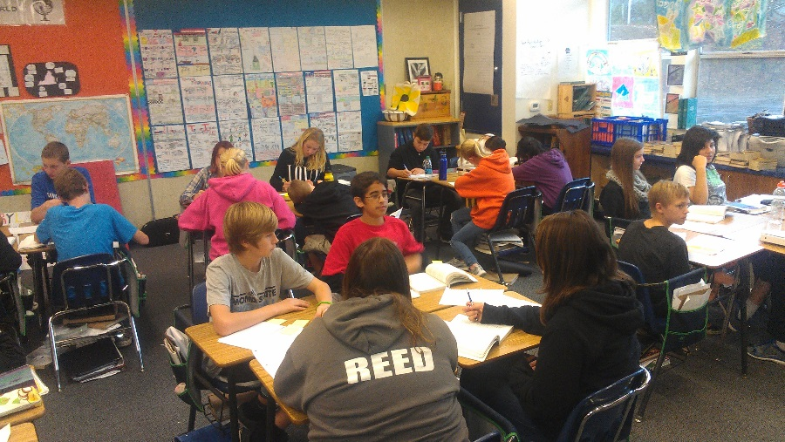
Appendix A
Literature Circles in Action:
Right: Students break into groups for discussion session.

Middle: Students create their novel’s word wall poster.

Bottom: Students share their on/off pages. On page are important text passages; off page are the student reflections and connections.
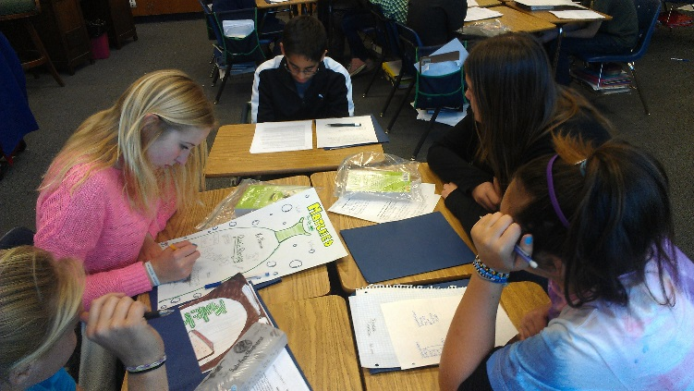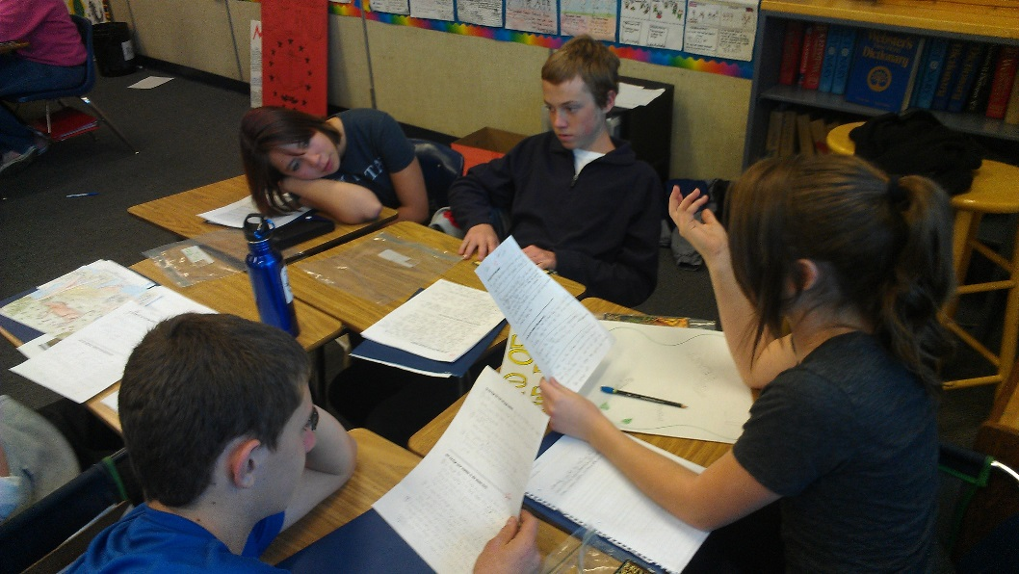

Appendix B

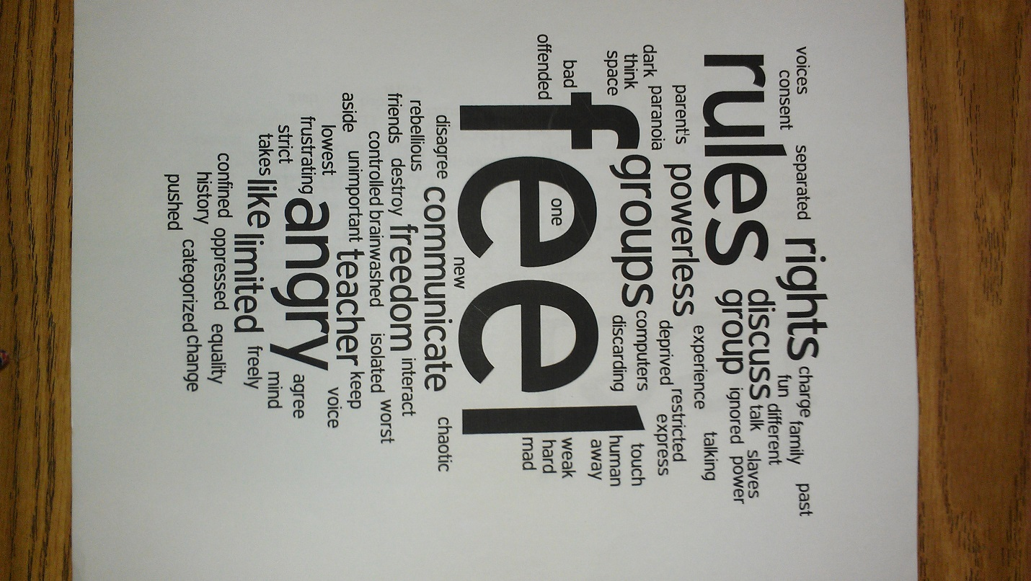

The Wordle created from my students’ responses from the introductory literature circle activity.

Appendix C
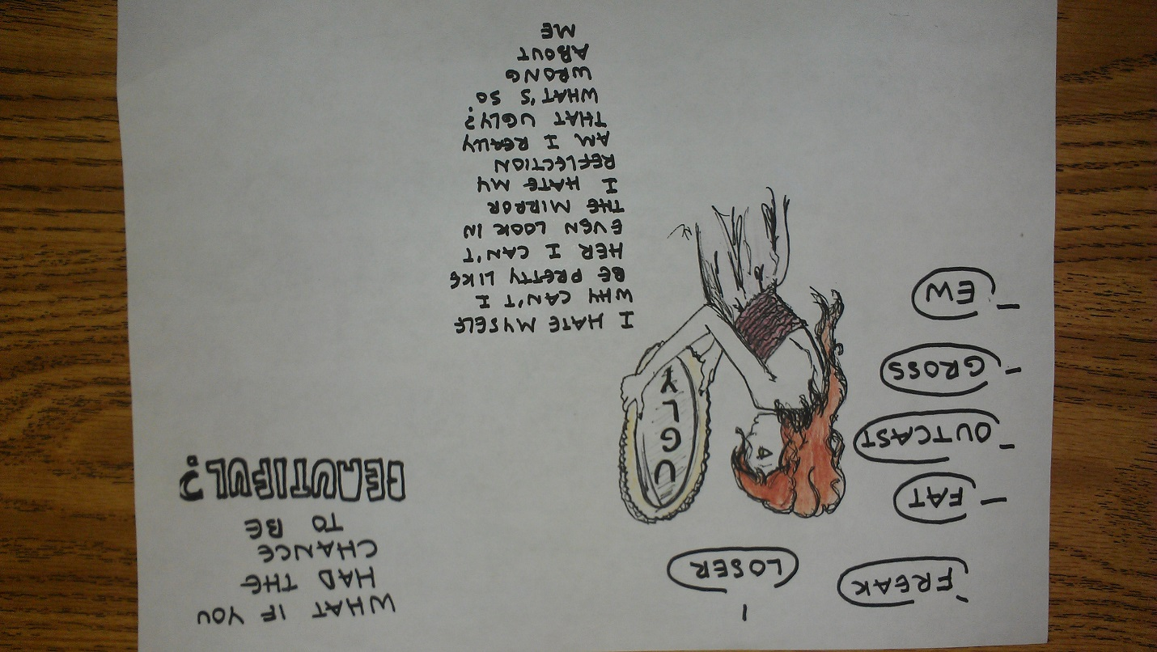

Character one-pager submitted by Nayelli; based on the Westerfield’s novel, Uglies

